Engaging with early readers
Children hate sitting still. They will be more engaged if you give them something to do.
Fidget spinners and squishy toys give their hands something to do.
However, you need them to be involved in the learning that you are seeking, so here are some ideas that involve activity with thinking and learning.
Alphabet Dice
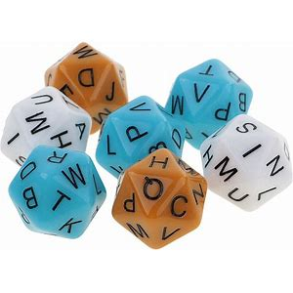
It is possible to get alphabet dice.
For grades 1-2 I suggest using only three dice.
Bring three of these dice with you and a cup. Ask the students to shake the dice in the cup and then roll them out onto the table. Can the student read the letters to you.
Ask them to write the letters on a piece of paper and then see if they can form a word using the letters.

Repeat a few times and record all the words that have been made.
You can also download a template and make some dice yourself from https://www.sparklebox.co.uk/previews/sb12082-alphabet-dice-net-templates/
For older students you can use all 5 dice and get students to make four letter or five letter words using the letters on each of the dice.
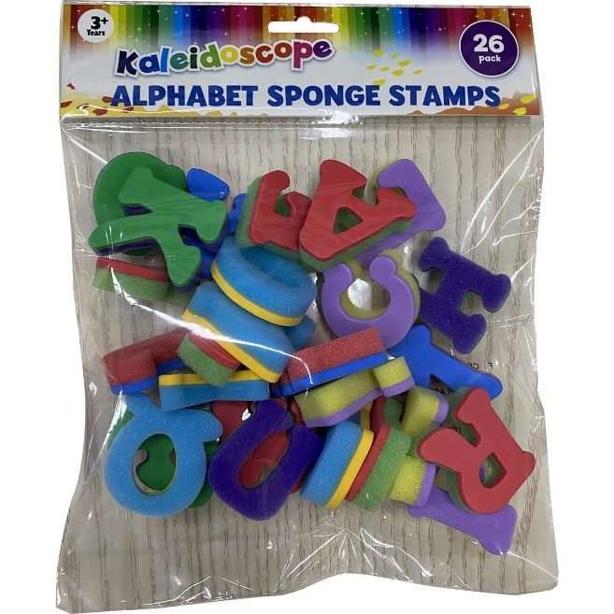
It’s in the bag
Big W has lovely foam alphabet stamps, as shown here. Place them all in a cloth bag and invite the student to select three items from the bag. Ask them to name the letters as they pull them out. Then see if they can use those letters to make a word. Keep drawing and using the letters, writing down each letter and the words that have been made in a notebook.
Of course, you could use a stamp pad and create words using the stamps to make the letters.
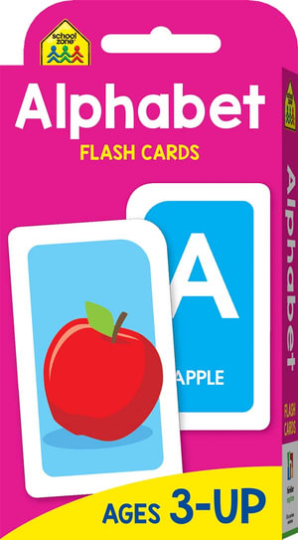
A different option would be to place the tiles from a scrabble game into the bag.
Alphabet Flash Cards
Use alphabet cards to play a game of snap. Divide the cards between you and the student. Then take turns placing a card on the discard pile. When two cards of the same letter are placed on top of one another the fastest person to say ‘Snap’ wins the pair of cards. The person who has the most cards at the end is the winner.

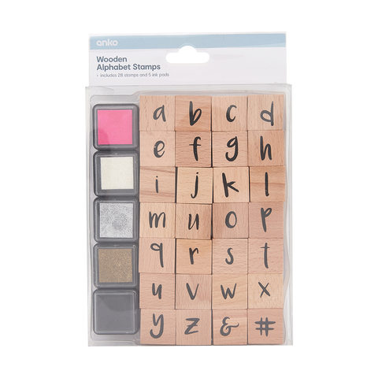
Using alphabet stamps
You can purchase a set of lower case alphabet stamps with small stamp pads for a few dollars at Kmart. Students love to ‘write’ their name using the stamps. Once they have mastered this they are ready to use the stamps to ‘write’ sight words or spelling words, or just important words from the book they are reading.
However, for learning to occur they need to write the words using a pen or pencil. So get them to write the words under the images created with the stamps.
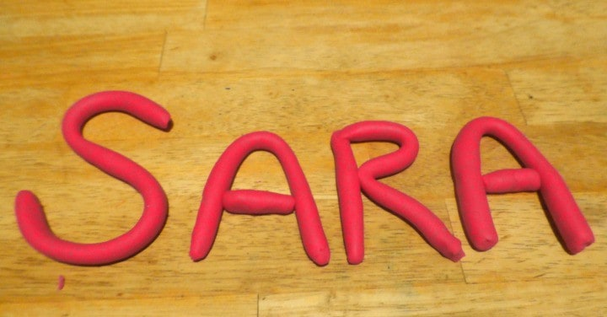

Making letters and words using playdough or chenille stems or string.
Young children love to play with play dough. It’s fun, it’s squishy, and it’s an excellent manipulative to have on hand when teaching the alphabet.
Playdough is easy to make but you can also buy little tubs cheaply at Kmart. Ask the student to roll the playdough into long thin snakes. Longer and slimmer is better than short and fat. The long skinny snakes are easier to fold into letters.
Ask them to make the letters that make up their name. Then ask them to make your name.
You can talk about capital letters and explain why we don’t usually use all capitals when writing their name. That leads to making Uppercase and lowercase letters.
They will get bored with this too so don’t expect them to make the whole alphabet. A few words. Perhaps a short sentence then pack it away and try something else.
Or start with the playdough and then try another medium such as chenille straws or string to make the letters.
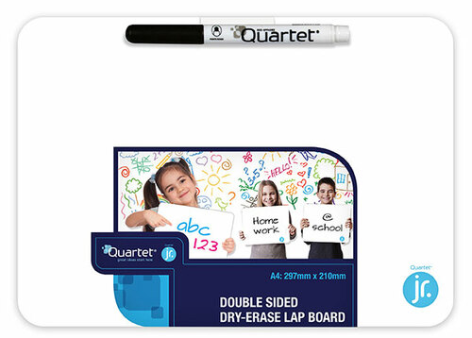
Mini white boards
Students love to practice their letter writing on a mini whiteboard. Errors can be quickly erased.
For students who like to draw, they can be rewarded for their writing practice with some drawing time.
Add in some physical activity
After reading for a short time of reading or writing allow your students to do some running on the spot or star jumps.
They enjoy the activity and it gets the blood pumping. Just ten start jumps can be enough to keep them interested for a bit longer.

