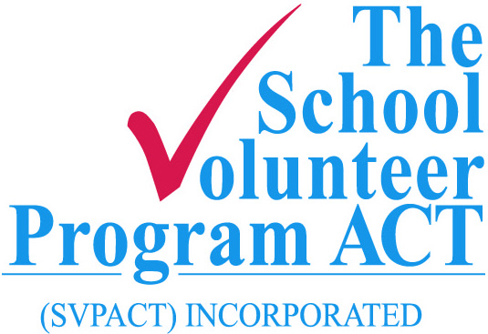

PO Box 3699
Weston Creek
Telephone 0405732837
SVPACT2018@gmail.com
www.svpact.org.au

CONFIDENTIAL APPLICATION
I am applying to be a Student Mentor with the School Volunteer Program ACT Inc.
My Preferred Area/School
Surname |  |  |  |  |  | Given Name
Preferred name for the badge | Mr/Mrs/Miss/Ms/Other
Address
 | State |  |  |  |  | Postcode
 | How long have you been at this address?
Previous Address
if less that 2 Yrs
 | State |  |  |  | Postcode
 | How long have you been at this address?
Telephone |  |  |  | Mobile
Email
Date of Birth
Emergency Contact | Name |  |  |  |  |  | Mobile Number
Working with Vulnerable People Registration Number
Registration Expiry Date

Background Interests/ Hobbies

Skills
Experience

Referee Details
Please provide contact details of TWO people who have known you for more than 2 years (other than family members). They can be friends or workmates who know you well.

Surname |  |  | Given Name
Telephone – Office Hours
Mobile |  | Home
Position/Relationship to you

Surname |  |  | Given Name
Telephone – Office Hours
Mobile |  | Home
Position/Relationship to you

CONFIDENTIALITY REQUIREMENT - Please read and complete and sign.

 | Full Name
I understand that as a volunteer working with SVPACT Inc at a school, I have the responsibility to respect and maintain the confidential nature of activities within the school.

I agree to comply with the Australian Privacy Principles of the Privacy Act 1988 as amended, and the confidentiality provisions of the ACT Education and Training Directorate Code of Conduct for persons working in schools

I declare the information in this application is correct, to the best of my knowledge.
Applicant’s Signature |  |  |  | Date
PLEASE NOTE |  | PRIVACY ACT
Personal data you have provided will be treated as confidential, in line with the Australian Privacy Principles of the Privacy Act 1988 as amended.

Completed Forms Send to the Secretary
Email svpact2018@gmail.com
Post SVPACT Inc. PO Box 3699, Weston Creek ACT 2611

